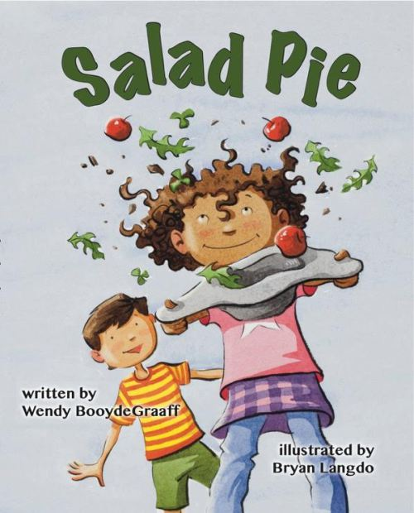
Salad Pie
by Wendy BooydeGraaff
Maggie is overjoyed to have the playground all to herself to make her Salad Pie, but then Herbert shows up.

READ THE BOOK, THEN…
TALK: Do you like empty playgrounds or playgrounds with lots of other kids?
SING: “Sing a Song of Sixpence”
Sing a song of sixpence a pocket full of rye,
Four and twenty blackbirds baked in a pie.
When the pie was opened the birds began to sing,
Oh wasn't that a dainty dish to set before the king?
Kid-friendly video here:
http://www.schooltube.com/video/3f0efd8bdde748b385da/Sing%20A%20Song%20of%20Sixpence
PLAY: Visit a playground, park, or even just your yard. Encourage your child to cook up his or her own creation from bits of nature. Pretend to eat it together, just like Maggie and Herbert.
WRITE: Help your child draw or write the recipe for his/her concoction.
READ MORE: If your child enjoyed Salad Pie, also try these:
- Leaf Man, by Louis Elhert – for more creating with nature
- Pete’s a Pizza, by William Steig – for more pretend cooking fun
- Jamaica’s Find, by Juanita Havill – for another great playground story

This Play & Learn packet created by Katie Van Ark, co-head of youth services at Fennville District Library in Fennville, MI as supporting material for the Every Child Ready to Read and 1,000 Books Before Kindergarten initiatives.

